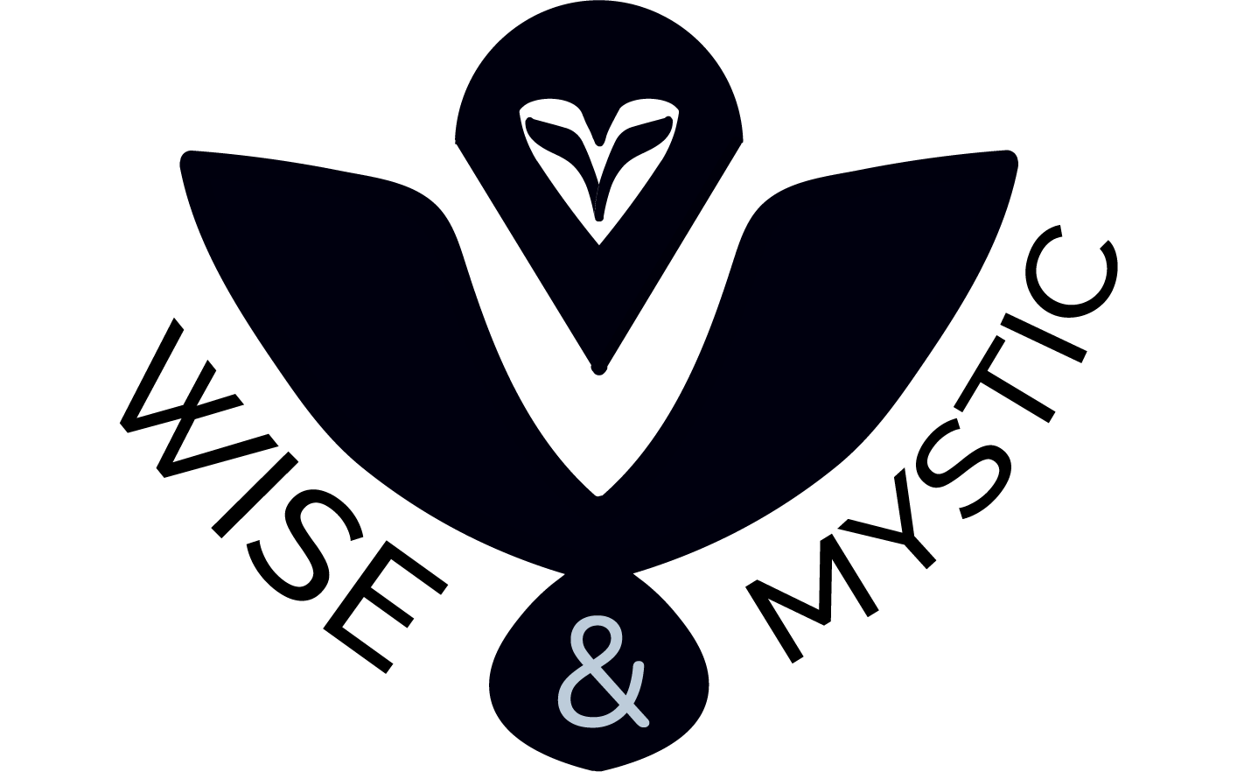

Contents

Project Information 2

Team Information 2

Introduction 2

Ways of Realization 3

Block Scheme 3

Work Plan 4

# Project Information

Our project is a geography quiz game, where you need to answer questions about different capitals and big cities in order to progress and earn points.

# Team Information

|  |
| --- |
| Roles in the team |
| Maksim Vasilev – Scrum Trainer |
| Mihail Petrov – Game Developer |
| Daniil Chebotarev – Game Developer |
| Daniil Furnika – Quality Assurance |

# Introduction

|  |  |
| --- | --- |
| What is our project? | Our project is a geography/history game where you have to answer questions about different capitals and big cities in Europe and travel between them. |
| Where you can find info about it? | You can read about the project on Github, where you may also find our work history and the project files. |
| How we kept in touch? | We communicated through Discord because it was the most convenient platform for the whole team. There we kept in touch and kept the work efficient. |
| What helped us make it? | Programs we used consisted of GitHub for file management and collaborative work, Visual Studio 2022 for code editing, MS Teams for communication, MS PowerPoint for our Presentation, MS Word for the documentation and Figma and Adobe Illustrator 2022 for our design. |

# Ways of Realization

|  |  |
| --- | --- |
| Task Distribution | The Tasks were distributed based on the skillset of everyone. We also notified each other when changes were made to the project so everyone was always up to date. This way our team was as productive as possible. |
| Task Completion | We held occasional meetings to track the development of the project and help each other progress further. It also helped us resolve issues and share ideas. |
| Deadlines | In these meetings we also discussed time management, how specific parts were coming along, what everyone had done in their specified time and what things should be completed in the near future. |

# Block Scheme

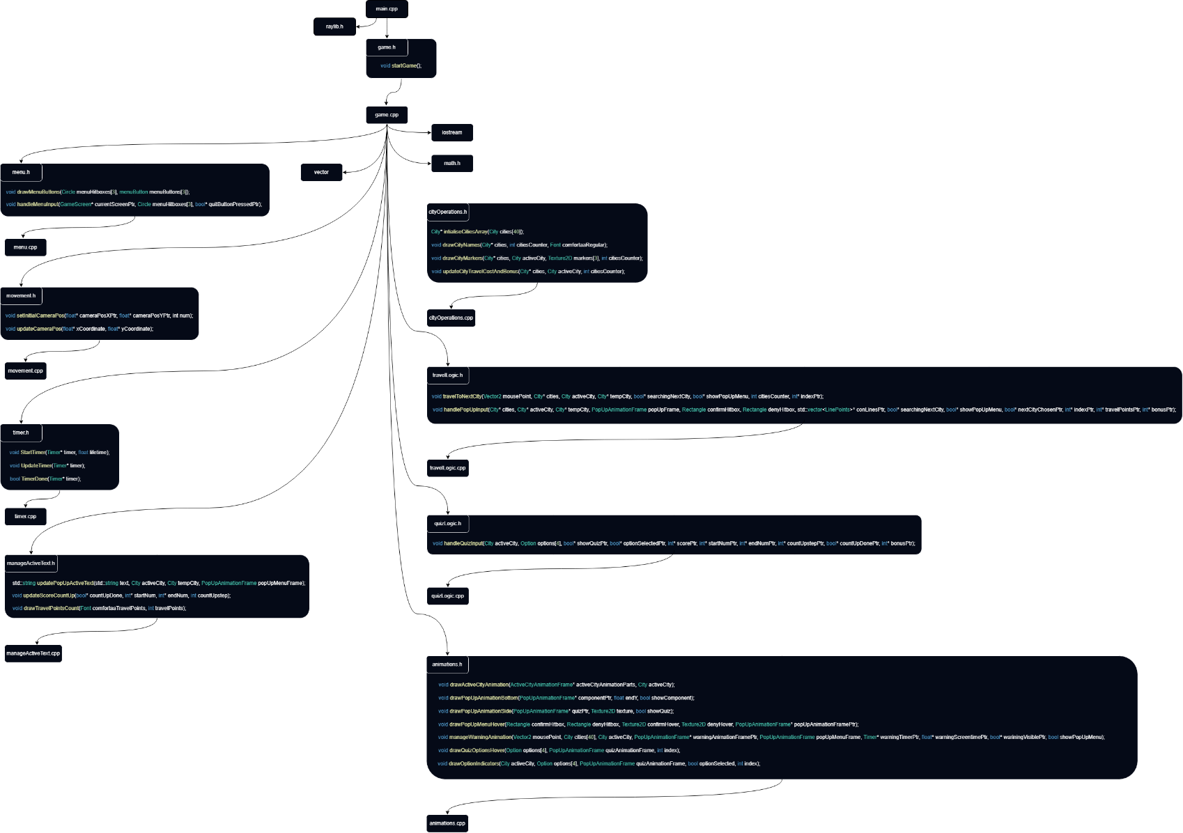

# Work Plan

|  |  |
| --- | --- |
| № | Task Breakdown |
| **1** | Set up Raylib  The library was set up by the back-end developers. Having it set up permitted further with graphics and textures. |
| **2** | Design game textures  We had to first create the map where the game would be played. |
| **3** | Create a game camera  The camera is used in order to navigate through the game map. |
| **4** | Implement cities  We had to choose the cities that would be featured in the game. |
| **5** | Create team logo  Our scrum trainer created the logo for the project. |
| **6** | Add quizzes information  We found information about the chosen cities and made questions and answers for all of them. |
| **7** | Add travel function  This function enables you to travel between different cities. |
| **8** | Add line-drawing function  The line-drawing function leaves a trail behind you when you travel. |
| **9** | Add score function  The score function tracks the amount of points that you have accumulated throughout your game session. |
| **10** | Finish game design  This includes things such as the hover animations, menu and icons. |
| **11** | Documentation  The documentation was created by our scrum-trainer using Word to summarise the project and explain its functions. |
| **12** | Presentation  The presentation was created by the scrum-trainer to explain the concept of the application, specify the used programs and establish the roles of the teams. |